UNIT 10 HW

Black-eared wheatears are small birds of Spain and Morocco. Males of the species demonstrate an exaggerated sexual display by carrying many heavy stones to nesting cavities. This 35-gram bird transports, on average, 3.1 kg of stones per nesting season! Different males carry somewhat different sized stones, prompting a study of whether larger stones may be a signal of higher health status. M. Soler et al. calculated the average stone mass (g) carried by each of 21 male black-eared wheatears, along with T-cell response measurements (in mm) reflecting their immune system strengths. Analyze the data and write a statistical report (by answering the questions below); treat the T-cell as the response and the stone mass as the explanatory variable. You may assume all criteria for regression and related t-tests are met. You can find the data for this problem in the file session10Data.xlsx. You may use R or SAS.

1. Analyze the data, providing the following:
   * 1. Provide a scatterplot with 99% confidence intervals of the regression line and 99% prediction intervals of the regression line.

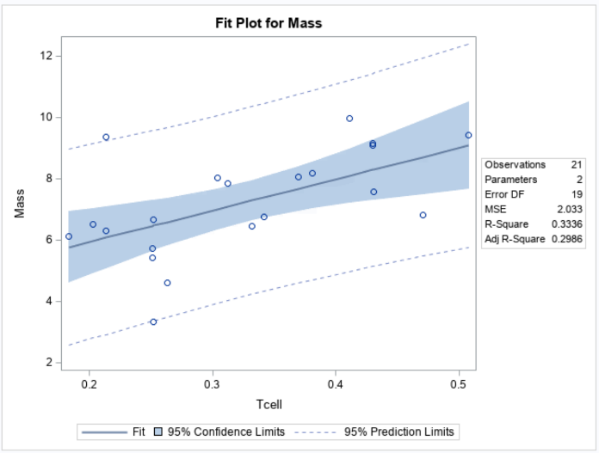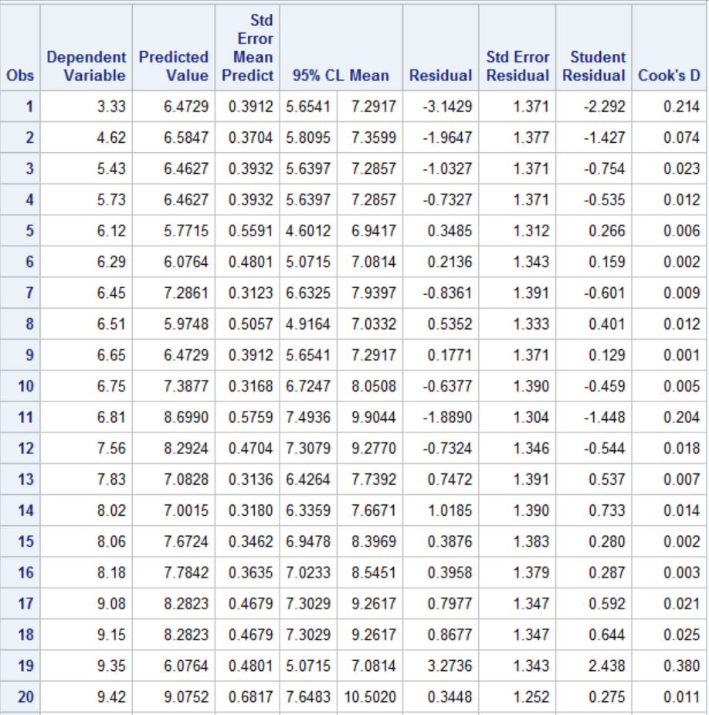

* + 1. Provide a table showing the t-statistics and p-values for the significance of the regression parameters $β_{0 }and β_{1}$ (as different from 0).

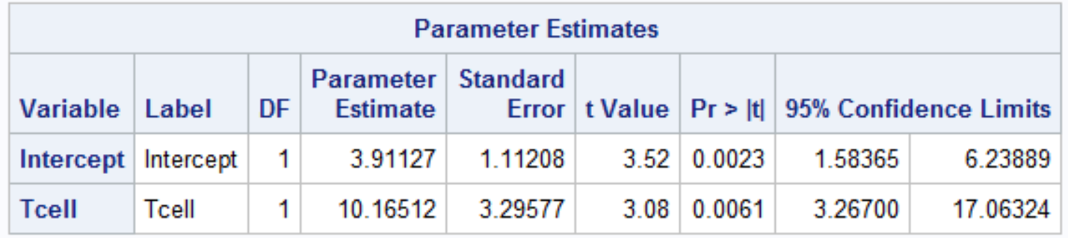

* + 1. Using the output in (b), show all 6 steps of ***each*** hypothesis test. (That’s one test for $β_{0 }=0$ and one test for $β_{1}=0$.) Find critical values in R. Your conclusion should include a confidence interval. Use alpha = 0.01.

**1**. Ho: Ho: = 0

Ha: Ha: ≠ 0

**2**. CVt: = 2.021

**3.** β1 = 10.16; β0= 3.91

SE(β1) = 3.29, SE(β0)=1.11

t(β1) = 10.16/3.29=3.08

t(β0) == 3.91/1.11= 3.52

CI β1= 10.16 ± 2.021(3.29)=(3.51, 17.40)

CI β0= 3.91 ±2.021(1.11)=(1.86, 6.15)

**4.** β1 p-value = .00061

β0 p-value = .0031

**5.** Reject Ho for β1

Reject Ho for β0

**6**. There is sufficient evidence at the alpha = .05 level of significance (p-value = .0061) to suggest that the data are linearly correlated (or that the slope is nonzero). There is not sufficient evidence to suggest the intercept is not zero for the regression line with confidence interval of (3.51, 17.40) and (1.86, 6.15). Consider collecting more data or eliminating outliers.

* + 1. State the regression equation. Be careful to use the mean Tcell or predicted Tcell, rather than just Tcell.
    2. Interpret the slope in the model (regression equation).
    3. Interpret the y-intercept in the model (regression equation).
    4. Find and interpret the 99% confidence interval for the mean t-cell response conditional on a stone mass of 4.5 grams.
    5. Find and interpret the 99% prediction interval for the predicted t-cell response given a stone mass of 4.5 grams.
    6. Provide a scatterplot of residuals.
    7. Provide a histogram of residuals with a normal distribution superimposed. It might be helpful to use studentized residuals, rather than regular residuals, with a normal curve overlay. Use R or SAS. (You may need to research this, such as googling “histogram with normal curve in R.”)
    8. Provide a measure of the **proportion** of variation in the response that is accounted for by the explanatory variable. **Interpret** this measure.

1. Using the data for Black-eared Wheatears, calculate by “hand” (using Excel) the following elements. (An example of much of this was in the PowerPoints and in the videos below.)
 ${\hat{β}}_{0 }and {\hat{β}}_{1}$

  1. The t-statistics and p-values for the hypothesis tests ( $β_{0 }=0$ and for $β_{1}=0$).
   2. 99% confidence intervals for the mean of Y when X = {3,4,5,6,7,8,9} grams. You do NOT need to make a Bonferroni (or any other type of) multiple interval correction, as the primary purpose of these intervals is to be able to plot confidence interval bands.
   3. 99% prediction intervals for the predicted Y when X = {3,4,5,6,7,8,9} grams. You do NOT need to make a Bonferroni (or any other type of) multiple interval correction, as the primary purpose of these intervals is to be able to plot prediction interval bands.
   4. Provide a plot for the confidence intervals and prediction intervals using Excel. Fully label your graph. (Use the regression equation and parts (c) and (d) above to create the plot.)

Videos for using Excel:

<http://screencast.com/t/ztSxTImiOk6s>

SE of ${\hat{β}}_{0 }and {\hat{β}}_{1}$ and RMSE: <http://screencast.com/t/V9gnhSwb>

Confidence Intervals: <https://www.screencast.com/t/ELiUGTe7Kc>

Prediction Intervals: <https://www.screencast.com/t/ap8WETxsGUqN>

CI and PI Plotting: <https://www.screencast.com/t/efrpHrqgYZnG>

Calibration Mean Gross: <https://www.screencast.com/t/Yu7eqiiH0X>

Calibration Single Movie: <https://www.screencast.com/t/2vS1lGqtJ>